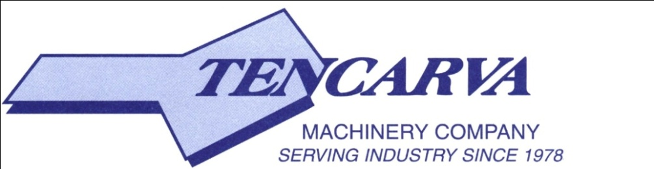

**1115 Pleasant Ridge Road, Greensboro, NC 27409**

NEW LOGO LINE

**Phone: 336-665-1435**

**Fax: 336-665-9585**

**Website: www.tencarva.com**

**Divisions: Hudson Pump & Equipment | ESSCO | Southern Sales Company | Saladin Pump & Equipment | Fischer Process Industries | Tri-State Coating & Machine**

|  |
| --- |
| **Tencarva Machinery Company, LLC - Trade Reference Information** |

Doing business as: Tencarva Machinery Company; Tencarva Municipal; ESSCO; Hudson Pump and Equipment; Southern Sales Company; Saladin Pump and Equipment; Fischer Process Industries; Tri-State Coating & Machine

Headquarters: 1115 Pleasant Ridge Road, Greensboro, NC 27409

Phone: 336-665-1435

Fax: 336-665-9585

Federal Tax ID: 56-1198229

D&B: 08-543-7028

**Bank Reference**

Bank of America, 800 Green Valley Road, Greensboro, NC 27408

Tel: 980-683-0544

Contact: Steven Stein

Email: [steven.k.stein@bofa.com](mailto:steven.k.stein@bofa.com)

Checking Account: 000021-208-186

**Trade References**

Goulds Pumps, Inc., 240 Fall Street, Seneca Falls, NY 13148

Email: credit.group@itt.com

Seepex, Inc., 511 Speedway Drive, Enon, OH 45323

Phone: 937-864-7150

Fax: 937-864-7157

Contact: gsnell@seepex.com

Gorman Rupp, 305 Bowman Street, Mansfield, OH 44901

Tel: 419-755-1011

Fax: 419-755-1233

Contact: alexandra.johnson@gormanrupp.com

Crane Pumps, PO Box 405367, Atlanta, GA 30384

Tel: 937-773-2442 ext. 3516

Fax: 937-773-7157

Email: ataylor@cranepumps.com